

[audio@aibrean.com](mailto:audio@aibrean.com) | voice.aibrean.com

****

[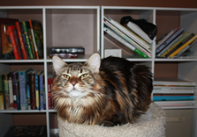](http://thedesigner.ws/wp-content/uploads/2011/07/mycat.jpg)

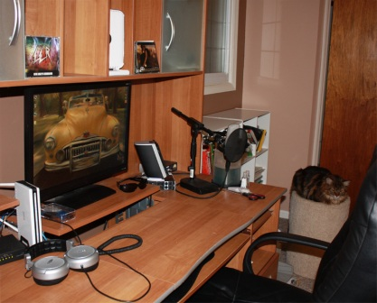

**LOCATION:**

Southwestern Ohio

**ACCENTS:**

My voice is medium to high. I can do any type of style from sultry to snotty, with an age range of child through adult (non-elder). I can do several accents including General American (native), Southern, and British. In my demos you can hear American, British, Russian (accent), and French (accent, limited language).

**CLIENTS:**

RSA Films (The Collectors animated commercial), Colonial Radio Theatre, BrokenSea Audio Productions, Darker Projects, Imagination Lane, Gypsy Audio, Misfits Audio, Mad Geek Productions, Giant Gnome Productions, DWAD, and TWERP.

**BIO:**

April Sadowski is a full-time graphic and web designer and an alumnus of [The School of Advertising Art](http://www.saa.edu/) (2003). She is a member of [AAF-Dayton](http://aafdayton.org/) and [Dayton Creative Syndicate](http://www.creativesyndicate.org/) and has won three ADDY Awards there for excellence in Web and Logo Design and has been nominated for an Emmy in Interactivity by NATAS Ohio Valley.

Besides design, April is also a writer, voice actor, and producer in her free time. She has written four novels: [Lady From Day](http://talesoforinda.com/), [The Great Marriage of Lunamae](http://talesfromorinda.com/), [The Cycle](http://thecycle.aibrean.com/), and Underland, and two audio dramas through[Nother Audio](http://nother.us/). She is a webmaster and producer at [Misfits Audio](http://misfitsaudio.com/serialsnape.php) (Snape’s Diaries, Tom Riddle’s Diary, Sally vs the Alligator, and Nutcracker Mania) and [Nother Audio](http://nother.us/" \t "_blank) (Lady From Day, Out of Time, Wings of the Past, and Partly Sunny).

April started out when she was 18, in high school, doing voice acting. After college, she invested in a studio mic (Shure KSM277), pop filter, and FireBox. In addition to offering herself for amateur, semi-pro productions, she is available for professional voice acting needs as well and a rate sheet is available from her website. Turnaround times can be as little as 8 hours, depending on length.

She lives in Xenia, Ohio with her husband and three cats (who frequent her office often). Pictured is Sasha, a Maine Coon who likes to plop and howl until April is awake in the morning and begs for belly rubs.